Environ 710 HW 11

Generalized Linear Models

Natalia Neal-Walthall

11.19.18

## Problem 1

#### Introduction

The purpose of this analysis is to evaluate the factors that led to damage of attack aircraft (bombers) during the Vietnam War. The database contains data from 30 strike missions involving two types of aircraft, the A-4 and the A-6. The regressor, x1, is an indicator variable (A-4=0 and A-6=1), and the other regressors x2 and x3 are bomb load (in tons) and total months of aircrew experience. The response variable (Y) is the number of locations where damage was inflicted on the aircraft.The null hypothesis of this study is that there is no significant relationship of aircraft damage to any of the above factors. The alternative hypothesis is that there is a significant generalized linear model relationship of aircraft damage to at least one of the variables. Interactions were excluded bases on the problem criteria.

#### Methods

To visualize the distributions and relationships, the data were plotted wth ggpairs. Based on this output, it appears that bomb load has a strong positive correlation to damage, aircraft type has a weak positive correlation, and months of service does not appear to be significantly correlated. The response variable is count data that is definitely not normal in distribution. It appears to be heavily skewed towards lower values. In addition, it has a bimodal distribution pattern, with a large peak at 1 and a second, lesser peak around 5. Bomb load and years of experience are closer to a normal distribution, though bomb load is also skewed towards lower values and appears to be correlated to plane type as well. Based on these distribution, it appears that analysis with GLM assuming a Poisson distribution is appropriate.

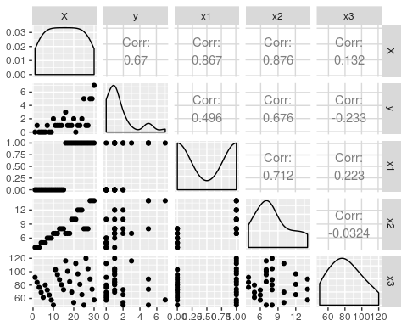 To determine the correct model, seven different generalized linear models were created. These models included the saturated model including all factors, each possible combination of factors, and a model including only each individual factor. Each reduced model was then compared to the saturated model with the Likelihood Ratio Test (LRT) in an ANOVA. The Null Hypothesis of each test is that the reduced model is adequate. The Alternative Hypothesesis is that the reduced model is not adequate.

dam1 <- glm(y ~ factor(x1) + x2 + x3, family = poisson, data = dat)  
dam2 <- glm(y ~ factor(x1) + x2, family = poisson, data = dat)  
dam3 <- glm(y ~ factor(x1) + x3, family = poisson, data = dat)  
dam4 <- glm(y ~ x2 + x3, family = poisson, data = dat)  
dam5 <- glm(y ~ factor(x1), family = poisson, data = dat)  
dam6 <- glm(y ~ x2, family = poisson, data = dat)  
dam7 <- glm(y ~ x3, family = poisson, data = dat)  
anova(dam1, dam2, test = "LRT")

## Analysis of Deviance Table  
##   
## Model 1: y ~ factor(x1) + x2 + x3  
## Model 2: y ~ factor(x1) + x2  
## Resid. Df Resid. Dev Df Deviance Pr(>Chi)  
## 1 26 25.953   
## 2 27 28.634 -1 -2.6812 0.1015

anova(dam1, dam3, test = "LRT")

## Analysis of Deviance Table  
##   
## Model 1: y ~ factor(x1) + x2 + x3  
## Model 2: y ~ factor(x1) + x3  
## Resid. Df Resid. Dev Df Deviance Pr(>Chi)   
## 1 26 25.953   
## 2 27 32.192 -1 -6.2386 0.0125 *  
## ---  
## Signif. codes: 0 '***' 0.001 '**' 0.01 '*' 0.05 '.' 0.1 ' ' 1

anova(dam1, dam4, test = "LRT")

## Analysis of Deviance Table  
##   
## Model 1: y ~ factor(x1) + x2 + x3  
## Model 2: y ~ x2 + x3  
## Resid. Df Resid. Dev Df Deviance Pr(>Chi)  
## 1 26 25.953   
## 2 27 27.220 -1 -1.2667 0.2604

anova(dam1, dam5, test = "LRT")

## Analysis of Deviance Table  
##   
## Model 1: y ~ factor(x1) + x2 + x3  
## Model 2: y ~ factor(x1)  
## Resid. Df Resid. Dev Df Deviance Pr(>Chi)   
## 1 26 25.953   
## 2 28 38.283 -2 -12.33 0.002101 **  
## ---  
## Signif. codes: 0 '***' 0.001 '**' 0.01 '*' 0.05 '.' 0.1 ' ' 1

anova(dam1, dam6, test = "LRT")

## Analysis of Deviance Table  
##   
## Model 1: y ~ factor(x1) + x2 + x3  
## Model 2: y ~ x2  
## Resid. Df Resid. Dev Df Deviance Pr(>Chi)  
## 1 26 25.953   
## 2 28 29.206 -2 -3.2527 0.1966

anova(dam1, dam7, test = "LRT")

## Analysis of Deviance Table  
##   
## Model 1: y ~ factor(x1) + x2 + x3  
## Model 2: y ~ x3  
## Resid. Df Resid. Dev Df Deviance Pr(>Chi)   
## 1 26 25.953   
## 2 28 50.537 -2 -24.584 4.588e-06 ***  
## ---  
## Signif. codes: 0 '***' 0.001 '**' 0.01 '*' 0.05 '.' 0.1 ' ' 1

AIC(dam1, dam2, dam4, dam6)

## df AIC  
## dam1 4 87.64922  
## dam2 3 88.33037  
## dam4 3 86.91589  
## dam6 2 86.90196

summary(dam6)

##   
## Call:  
## glm(formula = y ~ x2, family = poisson, data = dat)  
##   
## Deviance Residuals:   
## Min 1Q Median 3Q Max   
## -1.9188 -1.0473 -0.1518 0.1650 2.6331   
##   
## Coefficients:  
## Estimate Std. Error z value Pr(>|z|)   
## (Intercept) -1.70097 0.50685 -3.356 0.000791 ***  
## x2 0.23112 0.04677 4.942 7.72e-07 ***  
## ---  
## Signif. codes: 0 '***' 0.001 '**' 0.01 '*' 0.05 '.' 0.1 ' ' 1  
##   
## (Dispersion parameter for poisson family taken to be 1)  
##   
## Null deviance: 53.883 on 29 degrees of freedom  
## Residual deviance: 29.206 on 28 degrees of freedom  
## AIC: 86.902  
##   
## Number of Fisher Scoring iterations: 5

coef1 <- exp(coefficients(dam6))

#### Results

Based on the results of these comparisons, it is immediately apparent that the models containing only X1 & X3 as well as the model with both X1 & X3 are not adequate based on .05>p values for each. This is not surprising given that these factors did not appear to have a strong correlation upon initial examination of the data. It appears that all models containing x2 have roughly the same change in residual deviance, suggesting that these models are essentially the same. To check this, the AIC criterion for these models was compared and the value for all was within 2. Therefore, the minimum adequate model considers only the effects of bomb load on damage: Y = β0 + β1X2 With the coefficients obtained, the model would be: log(Y) = -1.7 + .23*X2*  
*However, because these values are on a log damage scale, interpretation is difficult. The model is easier to understand once coefficients are exponentiated: Y = .183 + 1.26*X2 So, for every 1 ton increase in bomb load, damage locations will increase by 26%.

To check for Overdispersion, the diagnostics plots were generated and examined. Aside from a couple of points that may have exerted too much leverage in the analysis, the data appear to be fine. Though there are three points that lie outside of a 1 to -1 standard deviation range, this is acceptable as roughly 5% should be expected to lie outside the range. As a final check, overdispersion was checked and found to be 1.09, indicating normal dispersion. Thus, rejection of the null hypothesis in favor of a GLM model which related bomb load to damage is appropriate. This relationshihp is shown in figure 1 below.

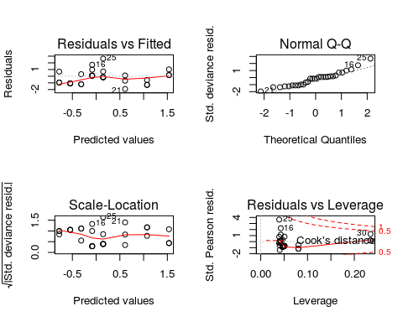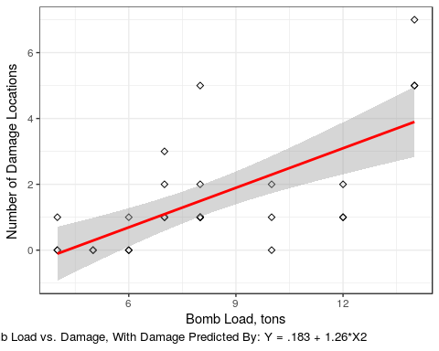 ##Problem 2

#### Introduction

The purpose of this analysis is to evaluate the factors that increase the number of moons associated with terrestrial planets, gas giants, and dwarf planets in our solar system. Planet size, mass, and distance from the planet are the regressors. Number of moods is the response variable. The null hypothesis of this study is that there is no significant relationship of number of moods to any of the above factors. The alternative hypothesis is that there is a significant generalized linear model relationship of number of moons to at least one of the variables and/or their interactions.

#### Methods

To visualize the distributions and relationships, the data were plotted wth ggpairs. Based on this output, number of moons appears to have a strong positive correlated to planet diameter and mass, with a weak negative correlation to distance. Planet Diameter and Mass also appear to have a strong correlation, so the factor with lower significance to the model will be removed. All data show a strong skew towards lower values. Based on these distribution, it appears that analysis with GLM assuming a Poisson distribution is appropriate.

## Loading required package: Sleuth3

## `stat_bin()` using `bins = 30`. Pick better value with `binwidth`.  
## `stat_bin()` using `bins = 30`. Pick better value with `binwidth`.  
## `stat_bin()` using `bins = 30`. Pick better value with `binwidth`.  
## `stat_bin()` using `bins = 30`. Pick better value with `binwidth`.

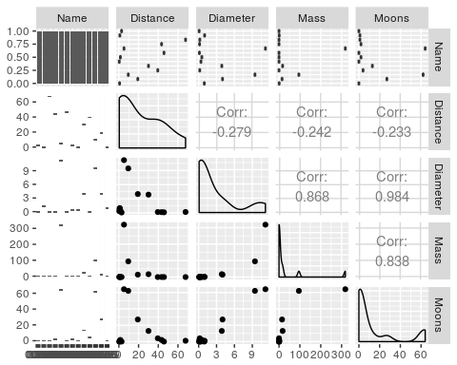 To determine the correct model, a saturated model was first created including all factors and their interactions. Diamater and Mass were then independantly removed to determine which factor is a better fit for the model. Based on change to AIC and residual variance, Diameter was chosen to be retained. Again, this is not surprising as this factor showed a stronger correlation to number of moons in the initial examination of the data. Finally, because the effects of Distance did not appear to be significant but the interaction between Distance and Diameter did, additional models were run in which each parameter was removed to examine the effects.

#### Results

Based on the AIC for the models, removal of the distance factor does not change the model, but removal of the interaction does, therefore all factors will remain in the model. However, when the model was checked for overdispersion, this was found to be an issue. Therefore, the model was rerun as a quasi-Poisson model, with the following minimum adequate model resulting:

Log(Moons) = β0 + β1(Distance) + β2(Diameter) + β2(Distance)(Diameter)

With the coefficients obtained, the model would be: Log(Moons) = .247 + .002(Distance) + .275(Diameter) + .0143(Distance)(Diameter)

However, because these values are on a log scale, interpretation is difficult. The model is easier to understand once coefficients are exponentiated:  
Log(Moons) = 1.28 + 1.002(Distance) + 1.32(Diameter) + 1.01(Distance)(Diameter)

So, for every 1 unit increase in distance, number of moons will increase by .2%. For every 1 unit increase in diameter, number of moons will increase by 32%, and for every 1 unit increase in both distance and diameter, number of moons will increase by 1%. It is likely that rescalin the distance data would make this easier to interpret, but since I don’t know the scale of the original it will remain as is.

Diagnostics revealed that data points 8 & 9 are potentially problematic. Both points appear to have too much leverage and fall well outside of an acceptable range for residuals. Were these my actual data, I would re-examine these data points and consider removal. As a final step, Moons were plotted as a function of distance and diameter, keeping the other parameter at a mean value. Because the graph scales made interpretation difficult, data were plotted as log values.

## Loading required package: zoo

##   
## Attaching package: 'zoo'

## The following objects are masked from 'package:base':  
##   
## as.Date, as.Date.numeric

##   
## Call:  
## glm(formula = Moons ~ Distance + Diameter + Mass + Distance:Diameter +   
## Diameter:Mass + Distance:Mass, family = poisson, data = dat1)  
##   
## Deviance Residuals:   
## Min 1Q Median 3Q Max   
## -1.53913 -1.02283 -0.04556 0.02589 1.97661   
##   
## Coefficients:  
## Estimate Std. Error z value Pr(>|z|)   
## (Intercept) -0.759804 1.154290 -0.658 0.5104   
## Distance 0.013042 0.012227 1.067 0.2861   
## Diameter 0.833128 2.664418 0.313 0.7545   
## Mass -0.006535 1.567339 -0.004 0.9967   
## Distance:Diameter 0.042239 0.057622 0.733 0.4635   
## Diameter:Mass 0.003420 0.128664 0.027 0.9788   
## Distance:Mass -0.010320 0.005164 -1.999 0.0456 *  
## ---  
## Signif. codes: 0 '***' 0.001 '**' 0.01 '*' 0.05 '.' 0.1 ' ' 1  
##   
## (Dispersion parameter for poisson family taken to be 1)  
##   
## Null deviance: 388.253 on 12 degrees of freedom  
## Residual deviance: 13.446 on 6 degrees of freedom  
## AIC: 61.462  
##   
## Number of Fisher Scoring iterations: 6

##   
## Call:  
## glm(formula = Moons ~ Distance + Mass + Distance:Mass, family = poisson,   
## data = dat1)  
##   
## Deviance Residuals:   
## Min 1Q Median 3Q Max   
## -2.5994 -2.1957 -0.4623 0.1328 5.4126   
##   
## Coefficients:  
## Estimate Std. Error z value Pr(>|z|)   
## (Intercept) 0.8989277 0.2731831 3.291 0.001 ***  
## Distance -0.0069511 0.0080330 -0.865 0.387   
## Mass -0.0180306 0.0021266 -8.479 <2e-16 ***  
## Distance:Mass 0.0054714 0.0004869 11.237 <2e-16 ***  
## ---  
## Signif. codes: 0 '***' 0.001 '**' 0.01 '*' 0.05 '.' 0.1 ' ' 1  
##   
## (Dispersion parameter for poisson family taken to be 1)  
##   
## Null deviance: 388.253 on 12 degrees of freedom  
## Residual deviance: 57.501 on 9 degrees of freedom  
## AIC: 99.516  
##   
## Number of Fisher Scoring iterations: 6

##   
## Call:  
## glm(formula = Moons ~ Distance + Diameter + Distance:Diameter,   
## family = quasipoisson, data = dat1)  
##   
## Deviance Residuals:   
## Min 1Q Median 3Q Max   
## -1.8941 -1.6885 -0.5906 0.3071 3.6900   
##   
## Coefficients:  
## Estimate Std. Error t value Pr(>|t|)   
## (Intercept) 0.246706 0.686573 0.359 0.72763   
## Distance 0.001999 0.019685 0.102 0.92133   
## Diameter 0.274679 0.062249 4.413 0.00169 **  
## Distance:Diameter 0.014347 0.005492 2.613 0.02815 *   
## ---  
## Signif. codes: 0 '***' 0.001 '**' 0.01 '*' 0.05 '.' 0.1 ' ' 1  
##   
## (Dispersion parameter for quasipoisson family taken to be 3.567853)  
##   
## Null deviance: 388.253 on 12 degrees of freedom  
## Residual deviance: 32.813 on 9 degrees of freedom  
## AIC: NA  
##   
## Number of Fisher Scoring iterations: 6

## df AIC  
## moon3 4 NA  
## moon4 3 NA  
## moon5 3 NA

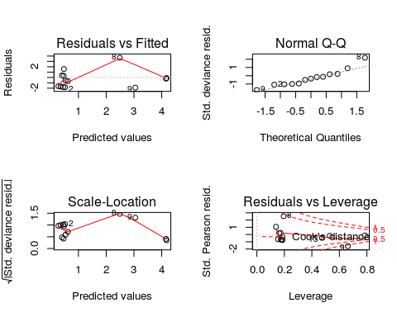

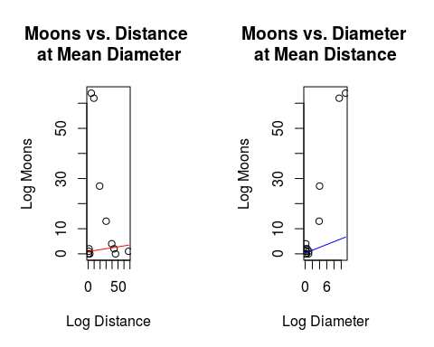

dat <- read.csv("~/710 Lab 11/AircraftDat.csv")  
ggpairs(dat)  
dam1 <- glm(y ~ factor(x1) + x2 + x3, family = poisson, data = dat)  
dam2 <- glm(y ~ factor(x1) + x2, family = poisson, data = dat)  
dam3 <- glm(y ~ factor(x1) + x3, family = poisson, data = dat)  
dam4 <- glm(y ~ x2 + x3, family = poisson, data = dat)  
dam5 <- glm(y ~ factor(x1), family = poisson, data = dat)  
dam6 <- glm(y ~ x2, family = poisson, data = dat)  
dam7 <- glm(y ~ x3, family = poisson, data = dat)  
anova(dam1, dam2, test = "LRT")  
anova(dam1, dam3, test = "LRT")  
anova(dam1, dam4, test = "LRT")  
anova(dam1, dam5, test = "LRT")  
anova(dam1, dam6, test = "LRT")  
anova(dam1, dam7, test = "LRT")  
AIC(dam1, dam2, dam4, dam6)  
summary(dam6)  
coef1 <- exp(coefficients(dam6))  
par(mfrow = c(2,2))  
plot(dam6)  
#wont knit with ovrdsp. Dont know why.  
#ovrdsp(dat$y, dam6)  
require(ggplot2)  
ggplot(dat, aes(x = dat$x2, y = dat$y)) +  
geom_point(shape = 5) +  
geom_smooth(method = glm, color = "red") +   
 xlab("Bomb Load, tons") +  
ylab("Number of Damage Locations ") +  
 labs(caption = "Figure one. Bomb Load vs. Damage, With Damage Predicted By: Y = .183 + 1.26*X2 ") +   
theme_bw()  
require(Sleuth3)   
dat1 <- ex2226  
attach(dat1)  
ggpairs(dat1)  
library(lmtest)  
moon1 <- glm(Moons ~ Distance + Diameter + Mass + Distance:Diameter + Diameter:Mass + Distance:Mass, family = poisson, data = dat1)  
moon2 <- update(moon1,~.-Diameter - Diameter:Mass - Diameter:Distance )  
moon3 <- update(moon1, ~.-Mass - Mass:Distance - Mass:Diameter, family = quasipoisson)  
moon4 <- update(moon3, ~.-Distance)  
moon5 <- update(moon3, ~.-Distance:Diameter)  
summary(moon1)  
summary(moon2)  
summary(moon3)  
AIC(moon3, moon4, moon5)  
coefs1 <- (coefficients(moon3))  
par(mfrow = c(2,2))  
plot(moon3)  
#plot describing relationship between Moon Count and Diameter at Mean distance  
par(mfrow=c(1,2), mar = c(5,5,5,5))  
x <- dat1$Distance  
g <- mean(dat1$Diameter)  
plot(x = dat1$Distance, y = dat1$Moons, main = "Moons vs. Distance \nat Mean Diameter", xlab = "Log Distance", ylab = "Log Moons" )  
curve((coefs1[1] + coefs1[2]*x + coefs1[3]*g + coefs1[4]*g*x), add=T, col="red")  
#plot describing relationship between Moon Count and Diameter at Mean distance  
x <- dat1$Diameter  
h <- mean(dat1$Distance)  
plot(x = dat1$Diameter, y = dat1$Moons, main = "Moons vs. Diameter \nat Mean Distance", xlab = "Log Diameter", ylab = "Log Moons" )  
curve((coefs1[1] + coefs1[2]*h + coefs1[3]*x+ coefs1[4]*h*x), add=T, col="blue")